Case Study

Olympic Football
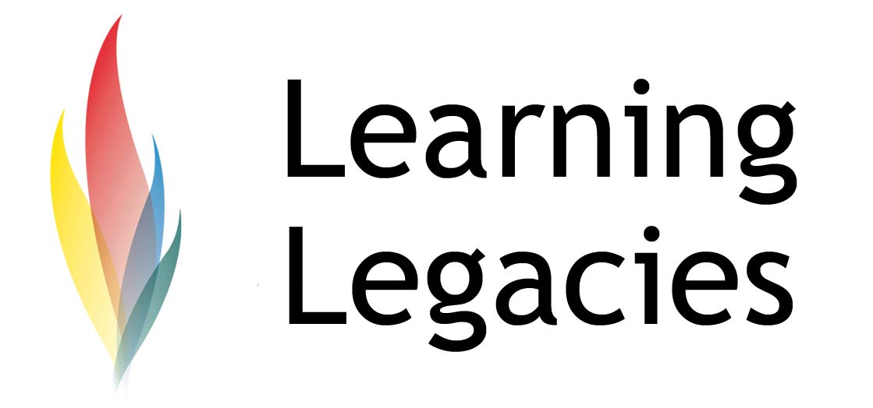
Sport & National Identity: the Case of Team GB Football

The concept of Olympic football has remained contentious for Great Britain throughout the history of the sport. This case study considers the reasons for such controversy, and introduces the concept of the nation state, national identity and politicisation of sport in the ongoing dialogue that surrounds Team GB and Olympic football.

Team GB will be managed by Olympic Head Coach Stuart Pearce, who (in accordance with FIFA regulations) must choose a squad of 18 players, which can include no more than three players over the age of 23.

Concerns over Athlete Burnout

Concerns over the potential burn out of players have been cited as a major cause for dissent amongst some of Britain’s most famous and well respected football figures. For example, Sir Alex Ferguson voiced his concern that young Manchester United's players should not be selected for both European Championship and 2012 Olympic Games matches.

Clearly, Ferguson is concerned that playing in both events would compromise Premiership performance, a great danger to the club given the massive financial investment that Manchester United has made in their players, and a great danger to their ability to win games and secure the highest possible media rights profits and sponsorship available to them as a result. Arsenal manager Arsene Wenger voiced similar concerns,

commenting that Olympics football is ‘not a real competition’. Arsenal players Jack Wilshere, Kieran Gibbs, Alex Oxlade-Chamberlain, Theo Walcott and Aaron Ramsey are likely to be involved in Great Britain's Olympic squad – meaning that a large contingent of players might derive from Wenger’s squad. Not all Premiership managers stand against the concept of Olympic football, however, and it remains to be seen how positively the British public stand behind Team GB when the Summer Games begin.

Both cite great concerns over the need for players to recover from a competitive and physically challenging Premier league season in time for the next, and cite concerns that after such a season, players cannot possibly be at their best to compete on a world stage.

There are many supporters of Team GB football, however. David Beckham has been vocal in his interest in playing for the squad in 2012, as have other key athletes, and Team GB Head Coach Stuart Pearce has stated that many players have voiced their willingness to represent their country in the Games.

Nationalistic Objections to a Combined GB Squad
Nationalistic concerns form the greatest central objection to the formation of a Team GB that unites England, Scotland, Northern Ireland and Wales. Sir Alex Ferguson commented that: “Speaking as a Scot I would say it is a no-no for us in case [world governing body] Fifa seizes the opportunity to try to make the home countries play together as Great Britain all the time, and we wouldn't want that. ."He did, however, concede that the choice might be best left to the individual athlete. FIFA chief Sepp Blatter countered such concerns by stating that the international status of the 4 nations would not be affected their inclusion in a GB Olympic team.

It is true that Wales, Scotland and Northern Ireland have decided not to formally endorse the concept of an Olympic 2012 GB football team. Gordon Taylor, Chief Executive of the Professional Footballers' Association (PFA), in favour of athletes from all four nations competing in the GB Team, has promised intervention by the PFA if players are subjected to intimidation or any negative ramifications as a result of their choice to participate. Taylor referred to any such treatment as ‘unsporting’ and ‘unnecessary’. He further stated that; ‘"I would not want [the team] to be made up of only English players. They should make every effort to make it representative of Great Britain and the nations contained within”. He further commented that the unwillingness of Wales, Scotland and Northern Ireland to endorse a combined team and allow the fielding of athletes from their respective nations would essentially be a case of “cutting off their nose to spite their face”.

Politicisation of Sport
Sport has long constituted a site of political discourse, with numerous examples of the use of sport as a means of promoting national pride and

Case Study

Olympic Football

WOMENS PARTICIPATION IN THE OLYMPIC GAMES
identity (particularly in Communist countries), as a means of diplomacy (for example, the ‘ping pong diplomacy’ of China-US in 1971), as a site of national conflict (for example, the 1978 Munich Games massacre of Israeli athletes by Palestinian terrorists), as a site of ideological protest (the 65-nation boycott of the 1980 Moscow Games, the 14-country boycott of the 1984 Los Angeles Games, and the proposed Indian boycott of the 2012 London Games) and as a means of establishing acceptance and support of contentious political regimes (such as the Third Reich, in the case of the Berlin Games).

The discourse surrounding national identity certainly drives much of the controversy that continues to rage over the inception of a Team GB that combines athletes from England, Scotland, Northern Ireland and Wales.
Discussion
- How did the choice of route for the Beijing Olympic Games raise political tensions?
- What other nations (aside from Nazi Germany, cited earlier), have used the Olympic Games as a means of gaining greater acceptance for a regime or nation state?
- What political tensions historically exist between England, Scotland, Wales and Northern Ireland, that would explain the current debate raging within football?
- The IOC state that they are not political, and that sport should not be political. Do you agree or disagree with such a statement?
Further Information
- Grix, J. (2010). From hobbyhorse to mainstream: Using sport to understand British politics. British Politics. Vol. 5, Issue 1, pp. 114-129. Palgrave Macmillan.
- Allen, D. (2011) The race for supremacy’: the politics of ‘white’ sport in South Africa, 1870–1910 Sport in Society. Vol. 14, Issue 6.
- Jaksa, K.L. (2011). Sports and Collective Identity: The Effects of Athletics on National Unity
SAIS Review. Vol. 31, No. 1, Winter-Spring 2011, pp. 39-41.

Olympic Football

Case Study

WOMENS PARTICIPATION IN THE OLYMPIC GAMES

This resource was produced as part of the 2012 Learning Legacies Project managed by the HEA Hospitality, Leisure, Sport and Tourism Subject Centre at Oxford Brookes University and was released as an Open Educational Resource. The project was funded by HEFCE and part of the JISC/HE Academy UKOER programme. Except where otherwise noted above and below, this work is released under a Creative Commons Attribution only licence.

Exceptions to the Licence
The name of Oxford Brookes University and the Oxford Brookes University logo are the name and registered marks of Oxford Brookes University. To the fullest extent permitted by law Oxford Brookes University reserves all its rights in its name and marks, which may not be used except with its written permission. The JISC logo is licensed under the terms of the Creative Commons Attribution-Non-Commercial-No Derivative Works 2.0 UK: England & Wales Licence. All reproductions must comply with the terms of that licence.

The Higher Education Academy logo is owned by the Higher Education Academy Limited and may be freely distributed and copied for educational purposes only, provided that appropriate acknowledgement is given to the Higher Education Academy as the copyright holder and original publisher.

Reusing this work
To refer to or reuse parts of this work please include the copyright notice above including the serial number. The only exception is if you intend to only reuse a part of the work with its own specific copyright notice, in which case cite that.
If you create a new piece of work based on the original (at least in part), it will help other users to find your work if you modify and reuse this serial number. When you reuse this work, edit the serial number by choosing 3 letters to start (your initials or institutional code are good examples), change the date section (between the colons) to your creation date in ddmmyy format and retain the last 5 digits from the original serial number. Make the new serial number your copyright declaration or add it to an existing one, e.g. ‘abc:101011:011cs’.
If you create a new piece of work or do not wish to link a new work with any existing materials contained within, a new code should be created. Choose your own 3-letter code, add the creation date and search as below on Google with a plus sign at the start, e.g. ‘+tom:030504’. If nothing comes back citing this code then add a new 5-letter code of your choice to the end, e.g.; ‘:01lex’, and do a final search for the whole code. If the search returns a positive result, make up a new 5-letter code and try again. Add the new code your copyright declaration or add it to an existing one.

